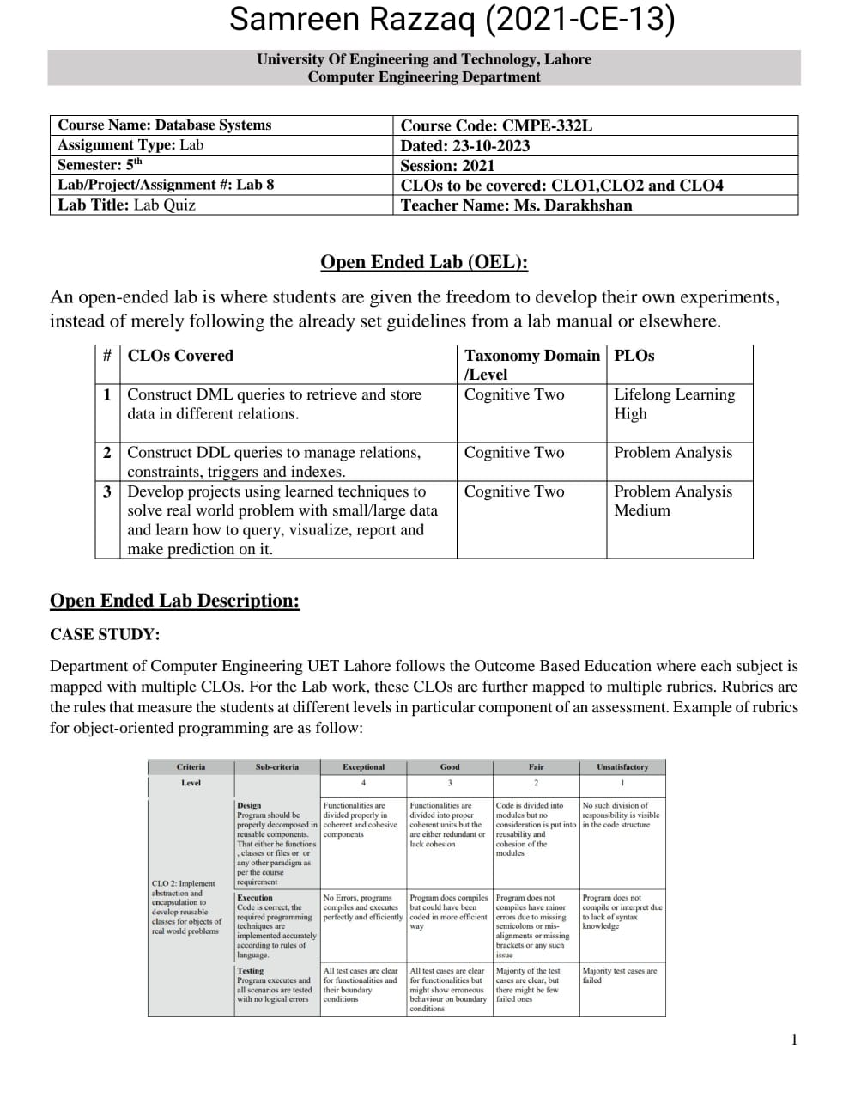

**Schema:**

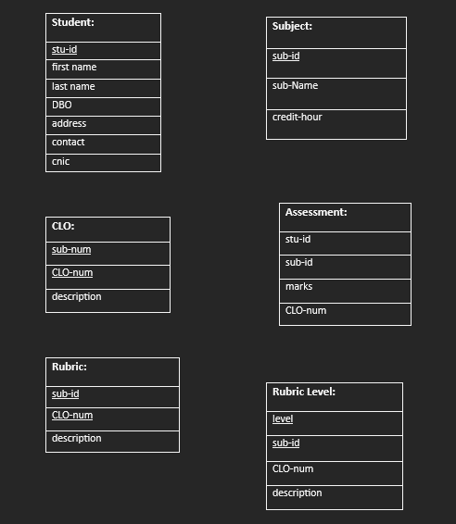

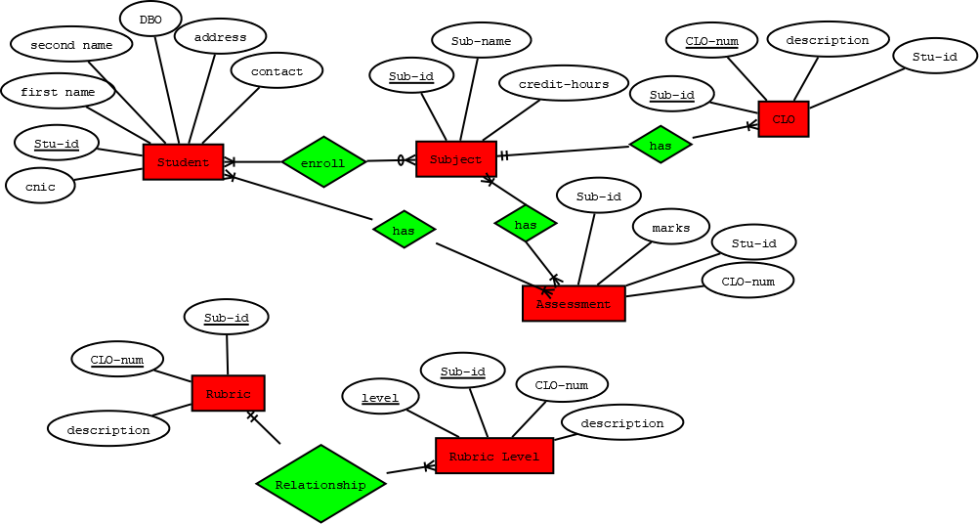**ER Diagram:**

**SQL Queries:**

--CLO-Wise Class Result:

SELECT

Assessment.[Stu-id] AS 'Student ID',

CLO.[CLO-num] AS 'CLO Number',

CLO.description AS 'CLO Description',

AVG(Assessment.marks) AS 'Average Marks'

FROM CLO

LEFT JOIN Assessment

ON

CLO.[Sub-id] = Assessment.[Sub-id]

AND CLO.[CLO-num] = Assessment.[CLO-num]

GROUP BY

CLO.[CLO-num], CLO.description, Assessment.[Stu-id]

ORDER BY

CLO.[CLO-num], Assessment.[Stu-id];

--Assessment-Wise Class Result:

SELECT

Assessment.[Stu-id] AS 'Student ID',

Subject.[Sub-Name] AS 'Subject Name',

Assessment.[Sub-id] AS 'Subject ID',

Assessment.[CLO-num] AS 'CLO Number',

Assessment.[marks] AS 'Assessment Marks'

FROM Assessment

LEFT JOIN Subject

ON

Assessment.[Sub-id] = Subject.[Sub-id]

ORDER BY

Assessment.[Sub-id], Assessment.[CLO-num], Assessment.[marks];

**Results:**

